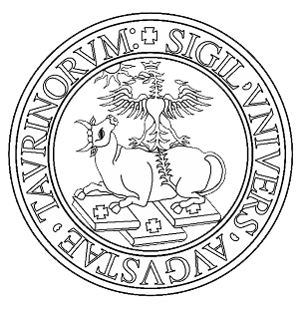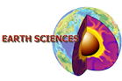
Earth Sciences PhD Courses – 2024-2025
organized by the Earth Sciences PhD Programme
Università degli Studi di Torino

Send to simona.ferrando@unito.it
Name and Surname ___________________________________________________
e-mail: ___________________________________ tel: _______________________
Education: __________________________________________________________
PhD (specialization, cycle):_____________________________________________
Supervisor __________________________________________________________

 | Course Title | CFU

